**STREET LIGHT THAT GLOWS ON DETECTING VEHICLE MOVEMENT**

**ABSTRACT**

The project is designed to detect vehicle movement on highways to switch ON only a block of street lights ahead of it (vehicle), and to switch OFF the trailing lights to save energy. During night all the lights on the highway remain ON for the vehicles, but lots of energy is wasted when there is no vehicle movement.

This proposed system provides a solution for energy saving. This is achieved by sensing an approaching vehicle and then switches ON a block of street lights ahead of the vehicle. As the vehicle passes by, the trailing lights switch OFF automatically. Thus, we save a lot of energy. So when there are no vehicles on the highway, then all the lights remain OFF. However, there is another mode of operation where instead of switching OFF the lights completely, they remain ON with 10% of the maximum intensity of the light. As the vehicle approaches, the block of street lights switch to 100% intensity and then as the vehicle passes by, the trailing lights revert back to 10% intensity again. High intensity discharge lamp (HID) presently used for urban street light are based on principle of gas discharge, thus the intensity is not controllable by any voltage reduction. White Light Emitting Diode (LED) based lamps are soon replacing the HID lamps in street light. Intensity control is also possible by Pulse Width Modulation (PWM) generated by the microcontroller. Sensors used on either side of the road senses vehicle movement and sends logic commands to microcontroller to switch ON/OFF the LEDs. Thus this way of dynamically changing intensity ON/OFF helps in saving a lot of energy. The project uses a PIC series microcontroller.

Further the project can be enhanced by using appropriate sensors for detecting the failed street light and then sending an SMS to the control department via GSM modem for appropriate action.

**BLOCK DIAGRAM**

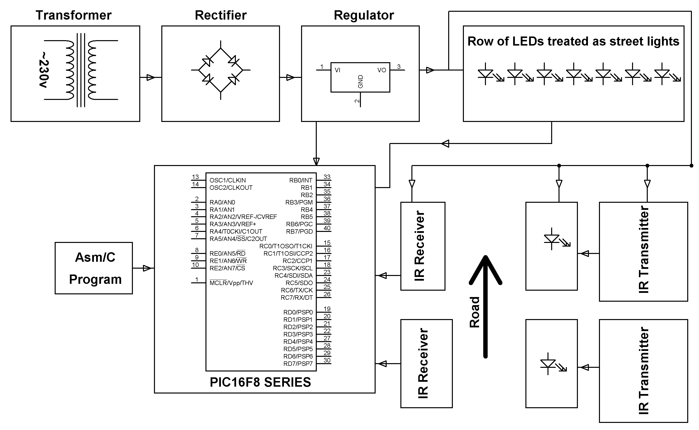

**SOFTWARE REQUIREMENTS:**

MPLAB & HI-TECH PICC Tool suite

Language: Embedded C or Assembly.

**HARDWRE REQUIREMENTS:**

PIC16F8 series microcontroller, Transformer, Diodes, Resistors, Capacitors, Voltage Regulator, LEDs, IR LEDs, Photodiodes, Transistors.